Supporting Pupils with Medical Conditions and Administration of Medicines Policy (WeST Template to be adapted locally by schools and ratified by WeST Community Councils)

Person(s) responsible for updating the template policy: | Richard Woodland – Director of Safeguarding
Policy type: | Trust template for local school adaptation
Approval level: | WeST Community Council
Date approved: | June 2026
Person(s) responsible for adapting template policy to local school needs | Ryan Howe
Date of next review: | June 2027
Review frequency: | Annual
Published on: | School website
Version History: | See final page

1. Statement of Intent
WeST expects all pupils with medical conditions to be properly supported so they can access the same education as their peers, including school trips and physical education. This policy sets out Trust-wide expectations that each school will adapt the information at Manor Primary School for local circumstances. It covers both physical and mental health needs and applies to on- and off-site activities.

2. Legal & Policy Context
This policy has regard to:
- Children and Families Act 2014 (Section 100)
- Equality Act 2010
- DfE: Supporting pupils at school with medical conditions (December 2015)
- DfE: SEND Code of Practice (January 2015)
- DfE: Keeping Children Safe in Education
- DfE: EYFS statutory framework (where a school has Early Years provision)
- DfE: Education for children with health needs who cannot attend school (December 2023)
- Department of Health: Guidance on the use of emergency salbutamol inhalers in schools (March 2015)
- Department of Health: Guidance on the use of adrenaline auto-injectors in schools (September 2017)

3. Roles & Responsibilities
Trust Board, through WeST Community Councils:
- ensure arrangements to support pupils with medical conditions are in place
- monitor implementation of this policy
- ensure insurance is adequate
Headteacher:
- ensure the implementation, resourcing and oversight of this policy and its associated procedures
Medical Conditions Lead: Ryan Howe, Headteacher
This person needs to be senior member of staff who has oversight of:
- maintaining the medical conditions register
- coordinating Individual Health Plans (IHPs)
- ensuring there are sufficient trained staff for on- and off-site activities
- ensuring appropriate cover when staff are absent
- briefing supply/cover staff
- briefing trip leaders about supporting pupils with medical conditions
- risk assessments for off-site trips
- medical records
- auditing equipment and records
Staff who administer first aid and/or medication
- will be appropriately trained and hold ‘in date’ certification
- administer first aid and/or medication in line with policy
- only administer medication for which they have been appropriately trained
- record all incidents of first aid and/or administration of medicines in line with policy
- may audit equipment and records in support of the Medical Conditions Lead (but the overall quality assurance responsibility for audit lies with the named senior staff member who is the Medical Conditions Lead)
- may be involved in IHP writing and reviews (but the overall responsibility for IHPs lies with the named senior staff member who is the Medical Conditions Lead)
Parents
- provide up-to-date information on medicines and consent
- engage in IHPs and reviews
Pupils:
- participate in planning and self-management where competent.
Healthcare professionals:
Healthcare professionals, such as School Nurses, specialist Diabetic Nurses etc., will advise on:
- diagnosis and treatment
- IHP content
- Staff training and competence

4. Policy Implementation & Accountability
The school, under the leadership of the Medical Conditions Lead, will be able to evidence:
- a current register of pupils with medical conditions
- there is enough competently trained staff to meet the first aid and medical requirements of staff and pupils in the school
- a training matrix listing when staff training renewals are due
- how cover arrangements for staff absence/turnover are typically handled
- briefings for supply teachers and visit leaders
- appropriate monitoring of IHPs (including parental involvement)
- appropriate monitoring of first aid and administering of medicine records
The WeST Director of Safeguarding will also monitor the implementation of this policy and its associated procedures through annual safeguarding reviews, supplemented by other monitoring activity as required.

5. Procedure on Notification of a Medical Condition
On notification that a pupil has a medical condition, the Medical Conditions Lead will:
- Record the pupil on the medical conditions register
- Consider whether the pupil will require a Personal Emergency Evacuation Plan (PEEP)
- Agree interim adjustments to enable safe access/inclusion from day one
- Convene an Individual Health Plan (IHP) meeting within 10 school days
- For mid-term moves or a new diagnosis, ensure new arrangements are in place within 10 school days
A summary of this procedure is available in the appendix.

6. Individual Healthcare Plans (IHPs)
IHPs are developed collaboratively with parents, relevant health professionals (e.g., school nurse) and the pupil, using the DfE template, and reviewed at least annually or earlier if needs change.
IHPs will include (as appropriate):
- condition details - triggers/signs/symptoms
- medication dose/side effects/storage
- other treatments
- testing and access to food/drink
- environmental adjustments
- educational/social/emotional support
- level of support including in emergencies
- roles/training/cover
- who needs to know
- consent/authorisation
- trip/PE arrangements
- confidentiality
- emergency actions (including Personal Emergency Evacuation Plans where necessary)
IHPs must be individual for each pupil. When considering common medical conditions, such as asthma, anaphylaxis, epilepsy or diabetes, generic templates must only be used as a starting point for an individualised IHP.
School IHP co-ordinator: Ryan Howe, Headteacher

7. Managing Medicines on School Premises
Principles:
- medicines are given only when essential
- all medicines must be provided by parents (the only exception to this are emergency asthma and adrenaline auto-injectors (AAIs))
- parental written consent is required
- the administration of all first aid and medicine is recorded
- pupils are encouraged to self-manage where appropriate
- non-prescription medicines may be administered with parental consent where the parent has provided the medication, subject to school assessment
- no medicines containing aspirin will be given to pupils under 16 unless prescribed.
- all medication (both over the counter and prescription drugs) must be stored securely, administered by authorised and appropriately trained staff and fully recorded
- pupils may self-carry controlled drugs only where this has been risk assessed and the pupil is deemed competent to do so
- emergency medicines/devices (e.g., inhalers, AAIs, glucose meters) must be easily accessible and not locked away. Locations are shown in the school medical map.
- Storage & disposal of medicines and equipment will follow manufacturer guidance, with unused medicines typically returned to parents for disposal
- Sharps must be disposed of in approved containers
LOCATION OF MEDICAL MAP: Teams/MAN-Staff Area/Shared/Medical Information/Medical 2025 26

8. Emergency Salbutamol Inhalers
School will support pupils with asthma in line with DfE guidance. Schools may purchase and hold emergency salbutamol inhalers and compatible spacers. Their use is permitted for pupils diagnosed with asthma/prescribed reliever inhaler and with parental consent when their own inhaler is unavailable or not working. Where an emergency inhaler is used parents will be informed on the same day.
Emergency asthma kits are stored centrally, clearly marked and not locked away. Regular checks and usage records are maintained.
Person responsible for Asthma Register: Alison Locke, Senior Administrator
Location of emergency asthma kits: Medical Room

9. Emergency Adrenaline Auto-Injectors (AAIs)
Schools may purchase and hold spare AAIs for emergency use on pupils at risk of anaphylaxis whose own device is unavailable or not working. AAIs are stored accessibly, clearly marked and not locked away. Staff are trained in recognition and use. All administrations are recorded and parents informed the same day. In a life-threatening emergency, adrenaline may be administered to save life.
Person responsible for Allergy/Anaphylaxis Register: Alison Locke, Senior Administrator
Location of emergency AAIs: Medical Room

10. Arrangements in EYFS (where applicable)
For Early Years provision, schools meet EYFS requirements, including medicines procedures, paediatric first aid and safeguarding policies.

11. Emergency Procedures
Detailed emergency actions are set out in IHPs. IHPs must be quickly accessible to school first aiders and to emergency personnel, e.g. paramedics. A member of staff must accompany a pupil to hospital until a parent arrives.
Location of emergency IHPs: Copies in child’s classroom and in the main office

12. Day Trips, Residential Visits and Physical Education
No pupil should be excluded from activities because of a medical condition. Visit leaders complete medical risk assessments, ensure immediate access to medicines/equipment, and brief supervising/supply staff. IHP summaries should travel with the pupil. Emergency access routes must be planned in advance and readily available via the trip risk assessment.

13. Record Keeping
We use DfE templates for parental consent, medicine administration and staff training records. Records of first aid incidents and the administration of medicines are stored securely and audited termly. The WeST Director of Safeguarding will review first aid records, IHPs and medication records as part of the WeST annual safeguarding review.

14. Unacceptable Practice
We adopt the DfE list of unacceptable practices, including:
- discouraging participation
- assuming medicine must only be given at home
- ignoring medical evidence
- penalising attendance for pupils with recognised medical conditions
- requiring parents to administer medicine in school
- preventing self-management by pupils where appropriate.

15. Liability & Indemnity
The Trust ensures appropriate insurance/indemnity for staff supporting pupils with medical conditions, including administration of medicines.
Zurich Insurance, copy kept in main office

16. Complaints
Concerns should first be raised informally with the Medical Conditions Lead. If this fails to resolve concerns then formal complaints should follow the school’s Complaints Policy.
Microsoft Word - WeST Complaints Policy and Procedure October 2025 - APPROVED

17. Home-to-School Transport (where applicable)
Where transport is provided, arrangements for medicines/emergency procedures are agreed with the transport provider and recorded in the pupil’s IHP.

18. Defibrillators (optional)
Schools may hold automated external defibrillators (AEDs). Where this is the case first aid staff are briefed on their location and trained in basic life support with the use of an AED. AED checks are logged through the Parago system.
Device location: Medical Room

19. Version History
Version | Date | Notes
1.0 | January 2026 | New version of the template policy provided, based on updates from previous template in line with DfE guidance

20. Templates
WeST recommends that schools adopt DfE templates onto branded documentation.
- IHP (Template A)
- Parental consent (Template B)
- Medicine Record – individual (Template C)
- Medicine Record all pupils (Template D)
- Staff training record (Template E)
- Contacting emergency services (Template F)
- Model parent letter (Template G).
These DfE templates are available at: https://www.gov.uk/government/publications/supporting-pupils-at-school-with-medical-conditions--3

21. Appendix
Model process for developing individual healthcare plans (Source: DfE 2015)
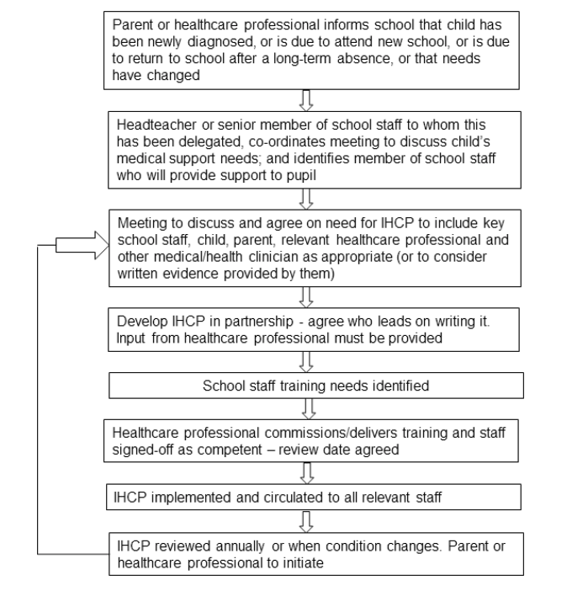

Given that medical needs sit within wider Special Educational Needs it is likely that the senior person responsible for IHPs will be part of the SEND team. However, this is a decision for schools within WeST to make at a local level.
In larger schools the coordination of IHPs may be delegated to a specific member of staff. Where this occurs there must be senior leadership oversight from a named person.
In settings where the Educational Visits Co-ordinator is not the Medical Conditions Lead there must be clear procedures in place to ensure that between them every trip has the appropriate risk assessments in place to meet the first aid and medical requirements
Throughout this policy the term ‘parent’ covers all parents/carers as named on the school’s information management system
Typically, a new IHP will be reviewed after 6 weeks and then once a term for the first year and annually thereafter. At any point new information is received about the medical condition the IHP should be reviewed. Where alternative review arrangements are in place the rationale for this should be clearly documented on the IHP.
https://assets.publishing.service.gov.uk/media/5a74eb55ed915d3c7d528f98/emergency_inhalers_in_schools.pdf
https://assets.publishing.service.gov.uk/media/5a829e3940f0b6230269bcf4/Adrenaline_auto_injectors_in_schools.pdf
DfE: EYFS statutory framework
https://assets.publishing.service.gov.uk/media/5ce6a72e40f0b620a103bd53/supporting-pupils-at-school-with-medical-conditions.pdf
DfE: Supporting pupils at school with medical conditions (December 2015)

