
Learning Map – French

How to use this Learning Map
Year 3 and 4* | Year 5 and 6*
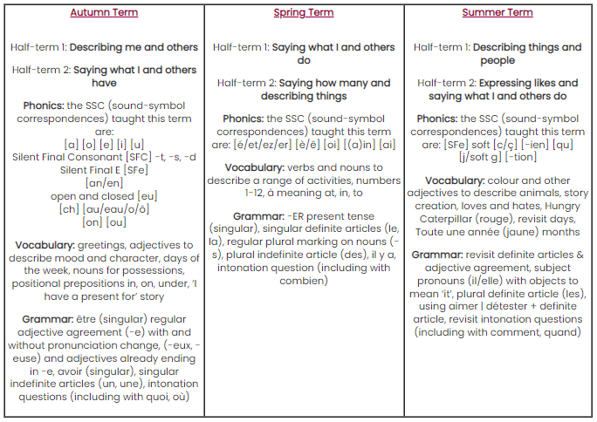 | 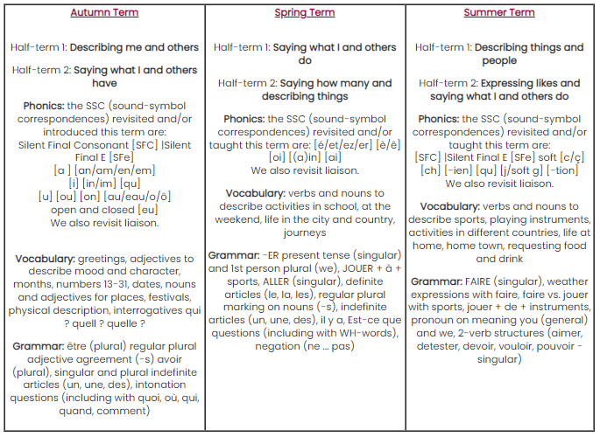
- The LM outlines the learning objectives that must be taught across the three strands of Language learning – phonics, gramma and vocabulary. These strands are taught through speaking, listening, reading and writing activities with culture embedded throughout.
Topic overview
*As of Autumn 2022-2023, Manor have begun a new SOW for MFL. As we teach through the SOW, each year group will become more accurate, fluent and confident in French and so progression across year groups will develop. We will begin in Autumn 2 by teaching Describing me and others

Language Progression: French KS2 curriculum*
Knowledge  Strands | Modes and modalities | Year 3 | Year 4 | Year 5 | Year 6
Phonics | Recognition & Production  (Sound (L) to print (W)) | I have learnt the SSC and phonics key words and remember them. I can match the French SSC I hear to print and transcribe accurately the SSC I know best. I enjoy listening to and joining in with simple songs and rhymes. | I can link SSC to new words I hear. I listen and transcribe SSC within single words with some success. I use sound-spelling links to follow when I listen and read. I enjoy listening to and joining in with simple songs and rhymes. | I have learnt about vowel combinations and stress patterns. I identify these when listening. I connect sound and spelling by transcribing a range of new words and parts of words. I enjoy listening to and joining in with songs and short poems. | I can listen and write short phrases including unfamiliar words more accurately, when focusing on transcription. I enjoy listening to and joining in with songs and short poems.
Phonics | Recognition & Production  (Print (R) to sound (S)) | I can readily read aloud the SSC and phonics key words. I can carefully sound out some unfamiliar words and parts of words with some success, focusing on a few SSC at any one time. | I can read aloud familiar words observing certain pronunciation rules (silent letters, accent/ stress markers, etc) and some unknown words. My pronunciation is usually comprehensible. | I can read aloud many familiar words with clear and comprehensible pronunciation. More slowly and carefully, I can decode unfamiliar words using SSC knowledge. | I read familiar words and short sentences aloud with clear and comprehensible pronunciation. I can read aloud single unknown words more readily.
Vocabulary | Understanding  (Aural (L) / Written (R)) | I understand around 100 words when I listen and read them as single items and in short sentences which describe people, places, things and actions. | I understand around 200 words when I listen and read them as single items and in short sentences which describe people, places, things and actions.  I look words up in an alphabetical word list. | I understand around 300 words when I listen and read them as single items and in short and compound sentences which describe people, places, things and actions. I am beginning to use the words I know in a sentence to work out likely meanings of single unknown words. I also use a dictionary. | I understand around 400 words when I listen and read them as single items and in short and compound sentences which describe people, places, things and actions. I can use the words I know in a sentence to work out likely meanings of single unknown words. I also use a dictionary.
Vocabulary | Production  (Oral (S) / Written (W)) | I can use around 100 words to engage in short exchanges; ask and answer questions; express opinions and respond to those of others; seek clarification and help. I can speak in and write sentences about people, places, things and actions, using familiar vocabulary and basic language structures. | I can use around 200 words to engage in short exchanges; ask and answer questions; express opinions and respond to those of others; seek clarification and help. I can speak in and write sentences about people, places, things and actions, using familiar vocabulary and basic language structures | I can use around 300 words to engage in short exchanges; ask and answer questions; express opinions and respond to those of others; seek clarification and help. I can speak in and write sentences about people, places, things and actions, using familiar vocabulary and basic language structures. | I can use around 400 words to engage in short exchanges; ask and answer questions; express opinions and respond to those of others; seek clarification and help. I can speak in and write sentences about people, places, things and actions, using familiar vocabulary and basic language structures.
Grammar¹ | Understanding  (Aural (L) / Written (R)) | I distinguish and understand (in listening and writing) singular and plural articles (indefinite and definite), singular verbs ÊTRE, AVOIR, (il y a), regular -ER, singular adjective agreement and position (-e, -eux/-euse), regular plural noun marking (-s), intonation questions, including question words quoi, où, combien, comment, quand) |  | I distinguish and understand (in listening and writing) singular and plural articles (indefinite and definite), singular and plural forms of ÊTRE, AVOIR, (il y a), regular -ER verbs, singular ALLER, FAIRE (including weather expressions), 2-verb structures with singular AIMER, DETESTER, DEVOIR, VOULOIR, POUVOIR) + infinitive, singular and plural adjectives (-(e)s, -eux/-euses), intonation questions (including with quoi, où, combien, comment, quand, qui), Est-ce que questions (with WH-words), negation (ne…pas)
Grammar¹ | Production  (Oral (S) / Written (W)) | To describe people, places, things and actions (in speaking and writing) I use singular and plural articles (indefinite and definite), singular verbs ÊTRE, AVOIR, il y a, regular -ER, singular adjective agreement and position (-e, -eux/-euse), regular plural noun marking (-s), intonation questions, including question words quoi, où, combien, comment, quand) |  | To describe people, places, things and actions (in speaking and writing) I use singular and plural articles (indefinite and definite), singular and plural forms of ÊTRE, AVOIR, (il y a), regular -ER verbs, singular ALLER, FAIRE (including weather expressions), 2-verb structures with singular AIMER, DETESTER, DEVOIR, VOULOIR, POUVOIR) + infinitive, singular and plural adjectives (-(e)s, -eux/-euses), intonation questions (including with quoi, où, combien, comment, quand, qui), Est-ce que questions (with WH-words), negation (ne…pas)
*As of Autumn 2022-2023, Manor have begun a new SOW for MFL. As we teach through the SOW, each year group will become more accurate, fluent and confident in French and so progression across year groups will develop over the next 4 years.
¹ The grammar features in lower KS2 (Y3/Y4) are all introduced in Y3 and revisited in new contexts in Y4 to deepen knowledge. The same applies to upper KS2 (Y5/6).
Key: L (Listening), S (Speaking), R (Reading), W (Writing)

